[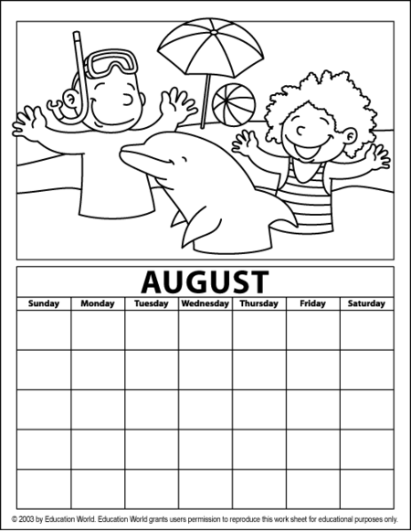](http://www.google.com.tr/url?sa=i&rct=j&q=+bo%C5%9F+takvim+boyama+sayfalar%C4%B1&source=images&cd=&cad=rja&docid=9hpq__vkherj6M&tbnid=MSy2Wfz7C4xxAM:&ved=0CAUQjRw&url=http%3A%2F%2Fwww.onceokuloncesi.com%2Fay-takvimi-boyama-mevsimlerler-grafi-icin-kullan-labilir-t20150.html&ei=UZgiUcbCKYPDhAf1lICQDg&bvm=bv.42553238,d.ZG4&psig=AFQjCNFZ5xUonHpMj12XdTcmgWpUynEulw&ust=1361308060437392)

bla bla bla.....