[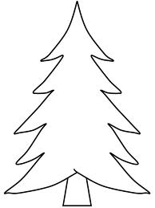](http://www.google.com.tr/imgres?q=%C3%A7am+a%C4%9Fac%C4%B1+boyama&hl=tr&tbo=d&rlz=1R2GGLL_trTR508&biw=1366&bih=612&tbm=isch&tbnid=BrWAjl0GTJGWrM:&imgrefurl=http://www.erguven.net/ders/Cam-Agaci-Boyama586&docid=0dxEs9rxY90tQM&imgurl=http://www.erguven.net/medya/www.erguven.net-tree14.gif&w=718&h=957&ei=BHbQUNiCOqSE4gTy8YDgBw&zoom=1&iact=hc&vpx=803&vpy=86&dur=6293&hovh=259&hovw=194&tx=127&ty=173&sig=105696736044477692681&page=1&tbnh=140&tbnw=105&start=0&ndsp=32&ved=1t:429,r:7,s:0,i:117) 