2012-2013 EĞİTİM-ÖĞRETİM YILI AYŞE FITNAT ORTAOKULU
1.DÖNEM 1.YAZILI YOKLAMA
(5. SINIF)
A) Fill in the blanks by using “north-south-east-west”(4x6=24 p)
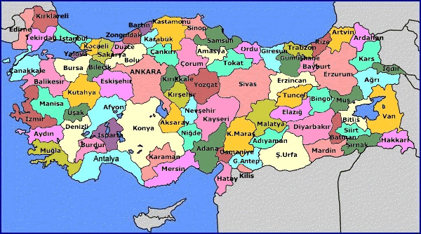

1.Ankara is in the __________ of Turkey.
2.Muğla is in the __________ of Turkey.
3.Ş,urfa is in the _________ of Turkey.
4.Mersin is in the __________ of Turkey.
5.Sinop is in the ___________ of Turkey.
6.İzmir is in the __________ of Manisa.
B) Write the numbers on the map.(4x7=28p)
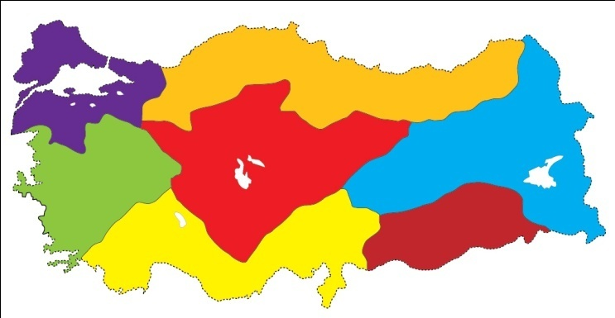

1-The Black Sea Region
2-The Marmara Region
3-The Eastern Anatolia Region
4-The Mediterranean Region
5-The Central Anatolia Region
6-The Aegean Region
7-The Southeastern Anatolia Region

C) Answer the questions.(4x3=12p)
Name: Mary Hunter
Country: England
Nationality: English

- What is her name? ………………………………………………………
- Where is she from? ……………………………………………………….
- What nationality is she? ……………………………………………………..

D) Write the directions(2x8=16p)
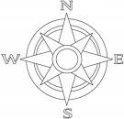

E) Write the words under the pictures 2x5=10p)
(forest, island, lake, mount, river)
1.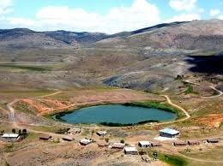 2. 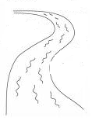 3. 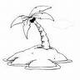4.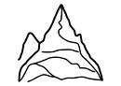5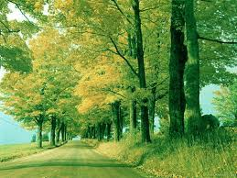.
__________ ___________ _________ ________ _________

F)WRITE THE NATIONS OF THE COUNTRIES(2x5=10p)
COUNTRIES NATIONALITIES
1)Turkey ______________
2)America ______________
3)Germany ______________
4)Spain ______________
5)France ______________ GOOD LUCK
TUĞBA ÇAĞLAR

