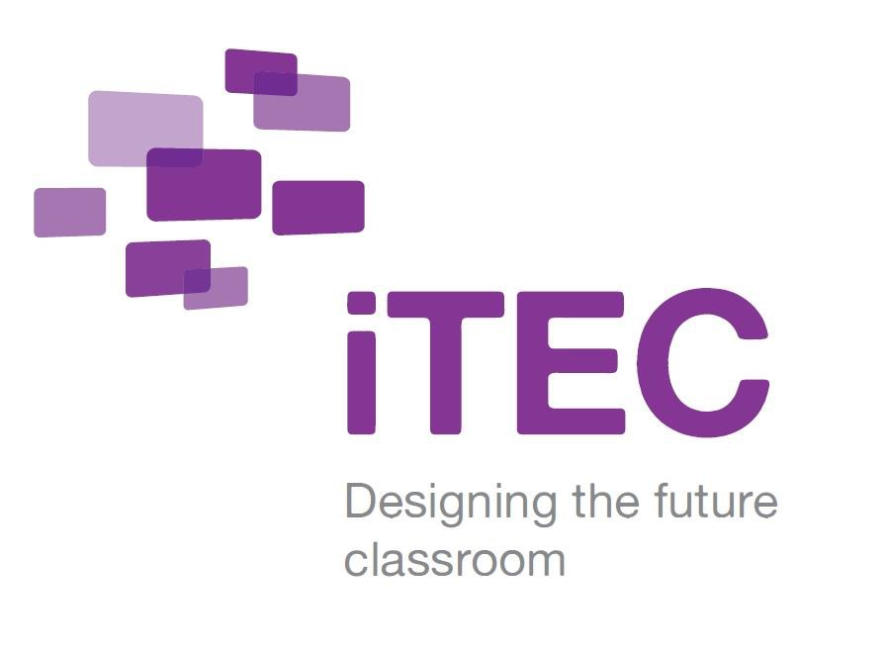

Case study story Austria

Pilot cycle 3: September – December 2012

itec.eun.org

CASE STUDY STORY: AUSTRIA

The Learning Story

Designing Maths Games

The teacher

The teacher is the ICT co-ordinator at the school. He is relatively new to iTEC, but the school is considered to be one of the most innovative in Austria and has a strong focus on e-learning. In the teacher’s view, the technical aspects of a project such as iTEC are fairly straightforward in a school such as this. However, the introduction of new pedagogies presents a much greater challenge for teachers.

The class

- Age of students: 8th grade (13-14 years) (who produced games for 9-10 year olds)
- Number in class: 12 students

The lesson/s

- The subject: ICT/Computer studies

Aims/Objectives:
  - To design a maths game for primary school students.
  - To program the game using Scratch
- Over what period of time 16 lessons over 2 months
- Location of lessons? In the classroom, in the computer lab and outside the school outside normal school hours

Resources

Desktop computer | Laptops | Digital media tools | Collaboration tools
Dropbox | Scratch | Corkboard | Virtual experiments/simulations
This case study provides evidence of

- Use of new learning spaces | - Constructivist pedagogies | - Effective use of digital tools
- Social/collaborative learning | - Creativity | - Expressiveness

What happened? Teacher and student experiences

The teacher divided the class of 12 students into groups of three. Each group was tasked with developing a maths games for primary school students, using the programming language Scratch. The end result of the process was to be a number of maths games for third grade students at the local primary school.
A key aspect of the activity was creating something which has an actual use outside the school. In this task, the students faced a technical challenge in developing their programming skills, as well as a pedagogical and design one, namely, ensuring the games they created were suitable, in terms of interest, topics and ability levels, for primary school students.

Developing technical skills

The project started in November, when the teacher presented his students a Scratch tutorial which they worked on individually to acquire the skills needed for the task.

Developing a game

Following this, the students were divided into groups of 4 according to their personal strengths; this meant that more creative students were mixed with those skilled at programming. The next step was to gather ideas and design a game in theory. Students used a program called Corkboard to help them to develop a concept; this tool allowed students to write and share ideas simultaneously. They also searched the web for existing maths games suited for primary schools, with those students with more developed programming skills looking at the programming codes and screening each program. Files were shared among the group using a Dropbox folder. As the groups worked, the teacher rarely intervened, allowing the students to be creative and to explore for themselves. Student were allowed to walk around the classroom and help each other. The teacher‘s role was one of a coach, supporting the students whenever necessary, but at the same time allowing them to design and produce their own product.
An important element was the healthy level of competitiveness between the student groups which was observed during the lesson; this gave the groups impetus, while still maintaining a co-operative atmosphere in the classroom.

Teacher’s comments (+/-)

- On student motivation and behaviour: “This class is usually louder and unfocussed because they are that good. Giving them something real to work on really increases their motivation and concentration”
- On changes to pedagogy: “Being a teacher since 1988, iTEC gave me some ideas to take new approaches in my pedagogy. It did not change it, but it broadened it quite a bit and after 20 years in school, you, as a teacher, are tired of telling the same stories over and over again.”

Main enablers?

- School infrastructure: Teacher opinion: “Being blessed with this kind of infrastructure and being used to having it, the implementation enabler was the existing IT infrastructure in our school”.
- Supportive classroom atmosphere: The level of co-operation in the classroom was highlighted by the NPC who felt it was relatively unusual to observe such a “good social climate”.

Students’ comments (+/-)

- The students felt that creating something which had a real use outside the school increased their motivation. They cared deeply about getting every detail of the game they were creating right as they wanted it to be appropriate for the target audience of primary pupils.
- However, this way of working was not particularly new for students in this school; they were used to innovative approaches: “We normally work that way in school. Our teachers try very hard not to stand in front of the class and act like experts. We do not like when knowledge is just thrown at us and we have to learn it and deal with it. In a lot of our classes we need to actively research and discover the knowledge.”

Key innovation/s… What is new/different overall ?

- Student attitudes: According to the teacher, the class is normally quite loud and sometimes the students are not as motivated and concentrated as they should be, but the introduction of the iTEC learning story led to a noticeable change in their attitudes. The teacher believes that this is partly because they needed to create something real.
- Role of the teacher: The changed pedagogical setting is something the teacher has to become familiar with, especially the notion of allowing students the freedom to explore and develop their own individual approach. “You just need to let them do the things and trust them. You are going to be surprised what they come up with.”

Links

- Examples of students’ games: http://scratch.mit.edu/galleries/view/189005

